**TestNG**

TestNG is a testing framework for Java Programming Language.

It is developed by Cedric Beust.

It is the advanced framework developed from Junit and Nunit.

Junit – Testing framework developed for java.

Nunit – Testing framework developed for Dot Net.

TestNG is developed to cover all the categories of tests unit, functional, End – to – end, and integration etc.

Features of TestNG:

* Parallel testing
* Data Provider – Pass the data to the test method.

1. How to install TestNG in Eclipse IDE

Step – 1: Install the TestNG in Eclipse IDE and restart the IDE.

Step – 2: Add the TestNG maven plugin in the POM.XML to the project.

Step – 3: Add TestNG Library into the project.

* Right Click on the Project
* Build Path
* Configure Build Path
* Libraries (Tab)
* Go to "Add Library" and click the button.
* Add the 'TestNG' Library and click Ok/Next.
* TestNG Library will be added to your project.

1. How to write test cases using TestNG

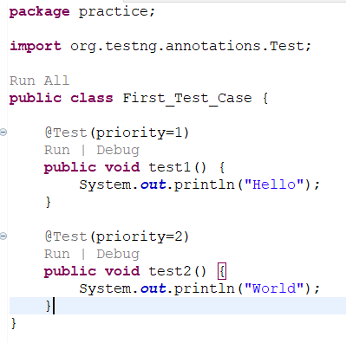

1. TestNG Annotations

* What is an Annotation?

Annotation is a form of metadata that can be added to the java source code.

* What are the Annotations available in TestNG?

@Test

@BeforeSuite

@AfterSuite

@BeforeClass

@AfterClass

@BeforeMethod

@AfterMethod

@BeforeTest

@AfterTest

@BeforeGroup

@AfterGroup

@DataProvider

@Parameters

@Factory

@Listeners

@Ignore

* How to use the Annotations?

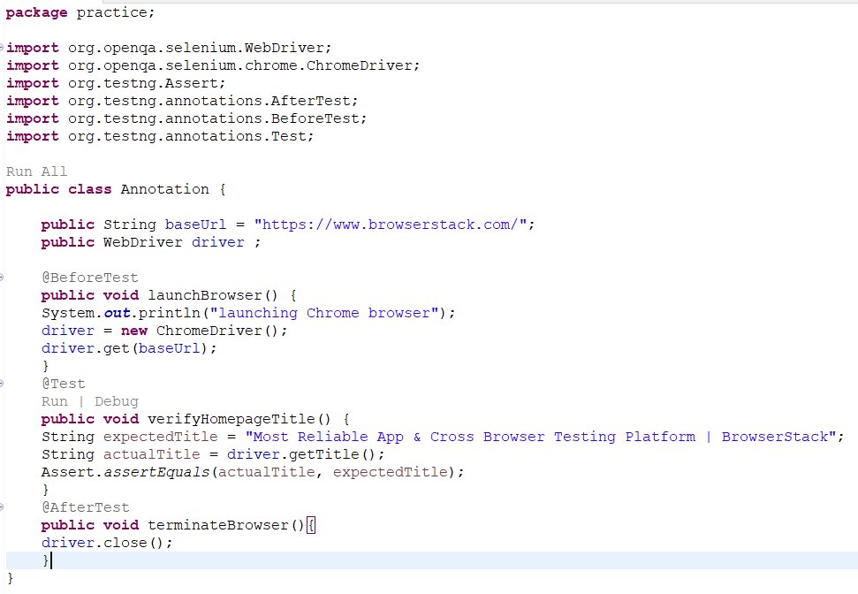

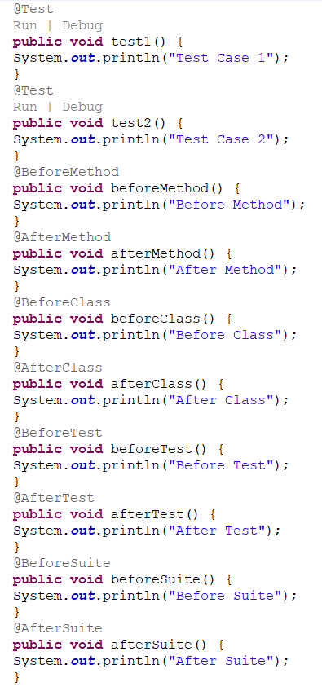

1. Assertions in TestNG

* What is meant by Assertion?

Assertion is an expression which will verify the actual test outcome with the expected test outcome.

* Are the assertions mandatory in TestNG?

Yes

* How to perform Assertions?

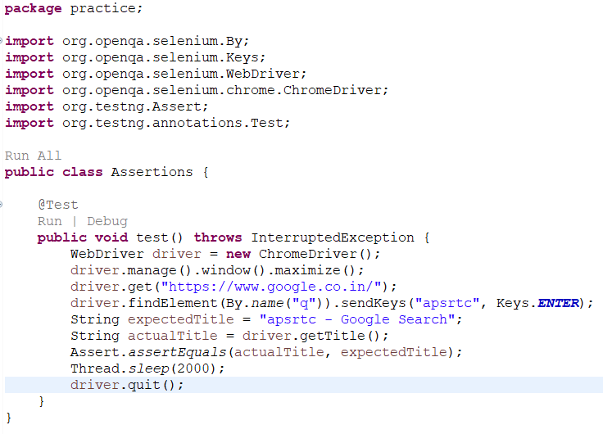

Types of Assertions:

* asserEquals
* assertNotEquals
* assertTrue
* assertFalse
* assertNull
* assertNotNull
* Hard Assertions VS Soft Assertion?

**Hard Assertion** is an assertion which throws the exception immediately upon the failure of assertion.

**Soft Assertion** is an assertion which cannot throws exception immediately upon the failure of assertion.

1. Basic Structure of TestNG XML file

* What is TestNG XML file?

It is a configuration file which contains the test execution details.

* What is the need of TestNG XML file?

For suppose if there are two test cases in class A, three test cases in class B and five test cases in class C. If I want to run randomly five test cases, then I need to store them in a separate file to run, that file is called TestNG xml file.

* How to create TestNG XML file?

Step – 1: Go to eclipse marketplace and install the xml editor.

Step – 2: Press CTRL+N and select a wizard xml and click next.

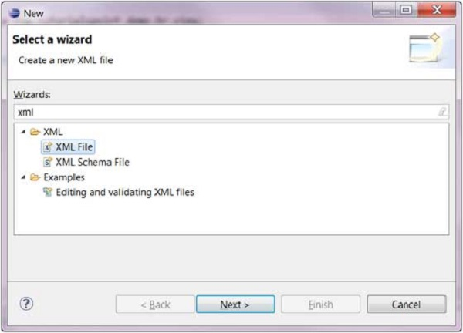

Step – 3: Go to the project and select the test folder, create a xml under the resources, and click finish.

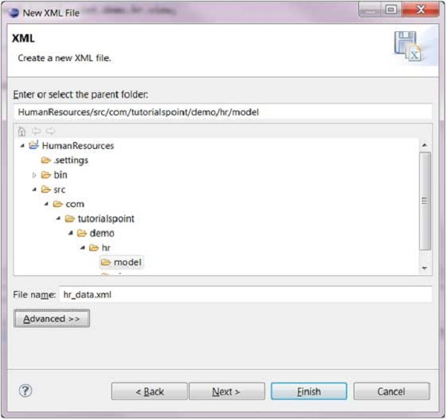

Step – 4: Now you can view a page like this.

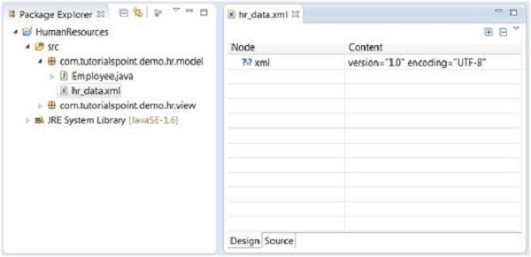

Step – 5: Go to source page.

* How to add tests to the TestNG XML file?

In this xml file, if we want to test the classes then no need to add the method tag.

We can add multiple classes in a class tag.

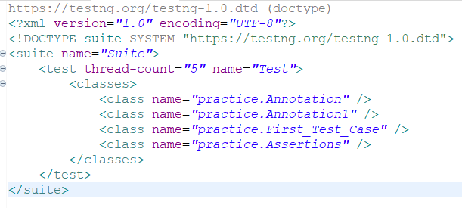

* How to execute tests using TestNG XML file?

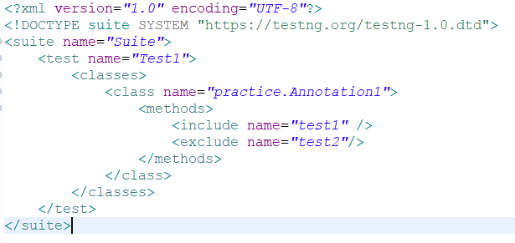

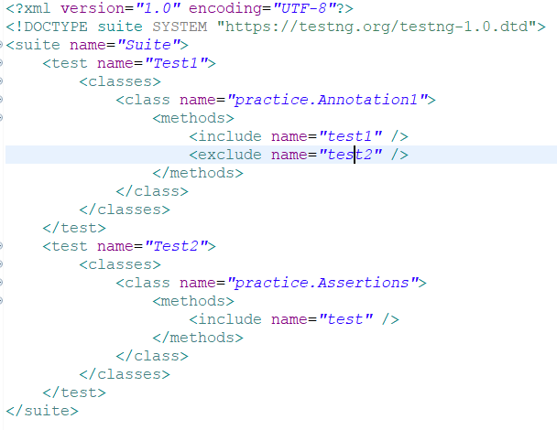

1. How to create test suite in TestNG?

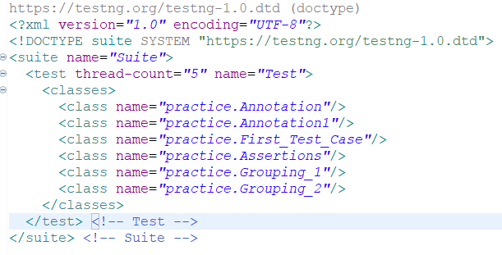

1. How to group test cases in TestNG?

* What is grouping & why we need grouping?

If you want to combine/categorize multiple tests under one set, then it is called as grouping. To combine multiple tests in a single set we need grouping.

* How to define grouping?

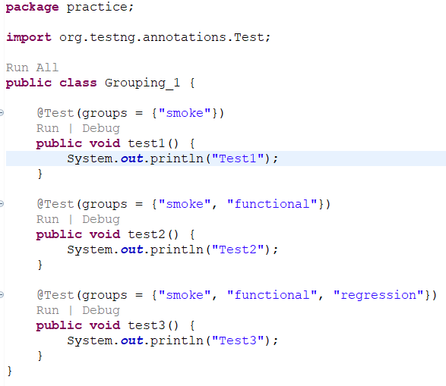

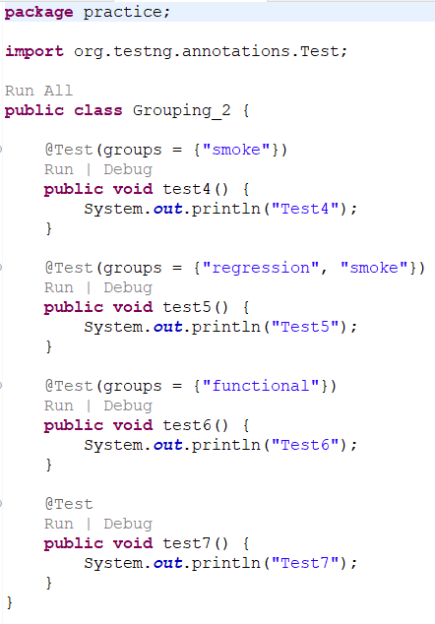

* Types of groups and how to use them?
* Test Groups

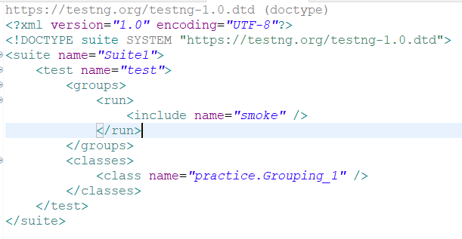

* Exclusion Groups

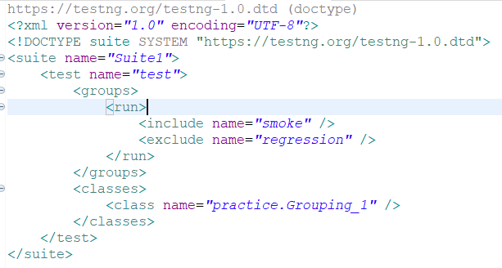

* Meta Groups (Group of Groups)

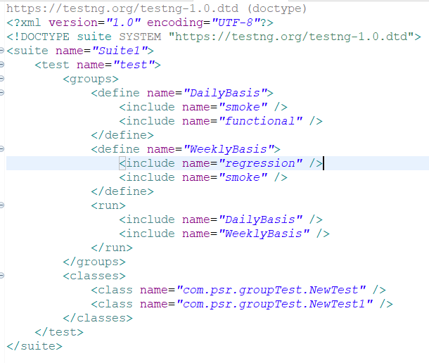

Note: Exclude tag is not applicable under define.

* Partial Groups

If you are assigning any group at the class level, then all the test methods present inside that class will be also part of that group.

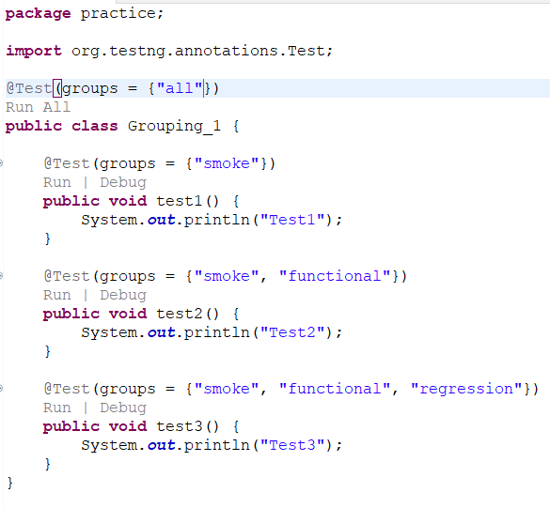

* How to execute the groups at suite level?

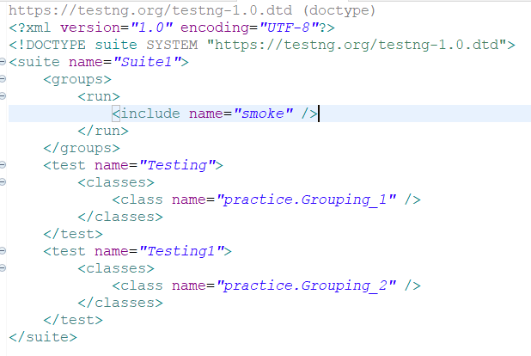

* How to execute the group at suite level + test level?

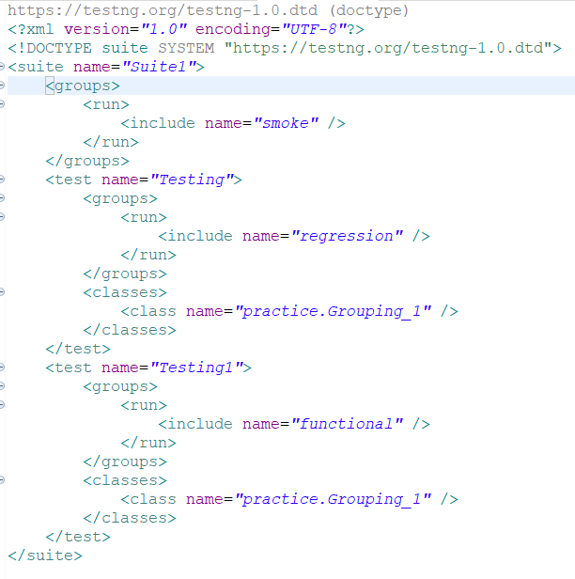

1. How to enable or disable test cases in TestNG XML file?

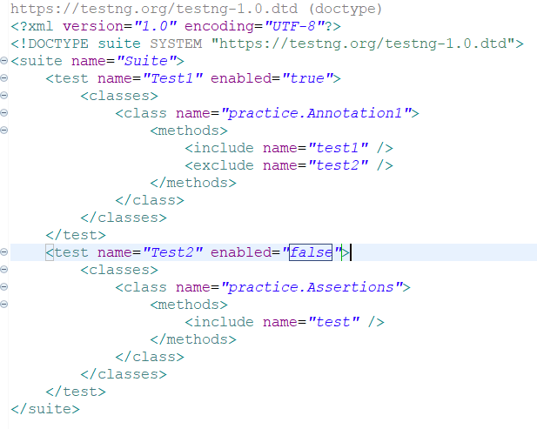

1. How to prioritize your tests in TestNG?

* What is a priority? Why we need to use the priority?

Priority is a parameter inside the test annotation. To execute test method in a certain order we need priority.

* How do we define the priority?

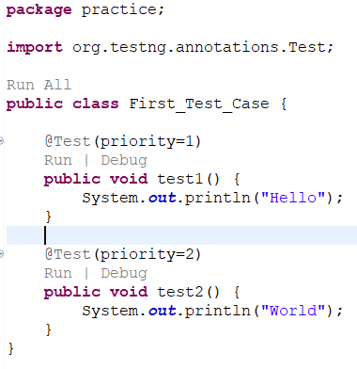

* What is the default value of priority?

Zero – It is going to be executed first.

* Can we pass the negative values to prioritize your tests?

Yes

* What happens if we pass the same priority value to the multiple tests?

It follows the ASCII value order to execute.

1. How to ignore tests in TestNG?

* How to ignore a specific test method?

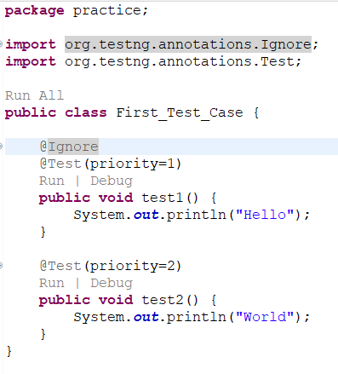

* How to ignore all the test methods in a class?

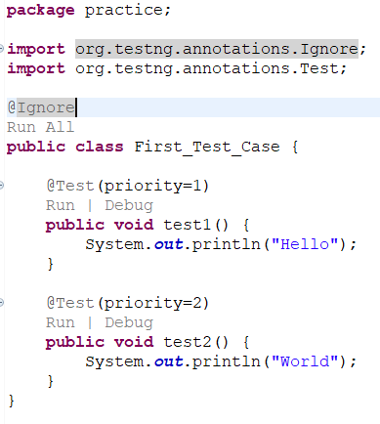

* How to ignore all the test classes in a package?

Step – 1: Right click on src/test/java and click on create a package and click on ‘Create package-info.java’.

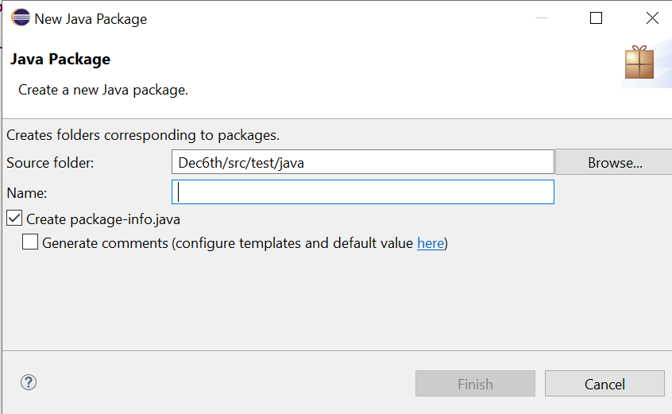

Step – 2: Type the name of the package you want to ignore and click on finish.

Step – 3: Add ignore at the package level.

